**SUPPLEMENTARY REQUIREMENTS RELEASE 2**

1. Field Validation
   1. Field: “Company Website”

**Scope:**

* + U.C 5.2 Edit Partner Information
  + U.C 5.3 Job Posting Management

**Requirements:**

* Field is mandatory and the system will not allow to proceed without a proper URL.
* If the field is left empty, ‘Company Website Required’ error message should get displayed.
* Field size is fixed to 2000 characters.
* Field should include a protocol (http:// or https://), domain and a top-level domain (.com, .org, .edu, etc..).
* ‘Please enter a valid URL’ error should get displayed if deviated from above URL structure.

**Conditions to Apply:** After the respective join points

1.2 Field: “Phone Number”

**Scope:**

* + U.C 5.2 Edit Partner Information
  + U.C 5.3 Job Posting Management

**Requirements:**

* Field is mandatory and the system will not allow to proceed without a proper Company Name.
* Field size is fixed to 10 integers.
* Field can only include numbers.
* If the field is left empty, ‘Required’ error message should get displayed.

**Conditions to Apply:** After the respective join points

1.3 Field: “Zip code”

**Scope:**

U.C 5.2 Edit Partner Information

**Requirements:**

* Field size is fixed to 5 Integers.
  + - * Field is mandatory and the system will not allow to proceed without a proper zip code.
* If the field is left empty, ‘Required’ error message should get displayed.
* ‘It should be numbers’ error should get displayed if anything other that integers are entered into the text field.

1. Connectivity:

**Scope:**

* U.C 2.5 Apply
* U.C 4.2 Edit Account Information
* U.C 4.3 Subscription Management
* U.C 4.4 Subscription Payment Process
* U.C 5.2 Edit Partner Information
* U.C 5.3 Job Posting Management

**Requirements:**

* + - If the connectivity is lost (or some other error) the system should retain cache to populate values once connectivity is restored.
    - User should receive relevant browser error message.

**Conditions to Apply:** After the respective join points

1. Data Flow In:

**Scope:**

* + U.C 4.1 View My Account (Image 1)
  + U.C 4.4 Subscription Payment Process (Image 2)
  + U.C 5.1 View Partner Information (Image 3)
  + U.C 5.4 Applicant Report (Image 4)

**Requirements:**

* 4.1 View My Account should indicate the active Subscription plan selected in 4.4 Subscription Payment Process. This data should only flow into 4.1 View My Account once the payment is successfully transferred.
* 4.1 View My Account should display partner information from 1.3 Partner (Sign up).
* 4.4 Subscription Payment Process should indicate the correct subscription plan selected by the partner in 4.3 Subscription Management.
* 5.1 View Partner Information should display information of the partner entered in 1.3 Partner (Sign up).
* 5.4 Applicant Report should list all the applicant applied to a specific job in 2.5 Apply

**Conditions to Apply:** After the respective join points

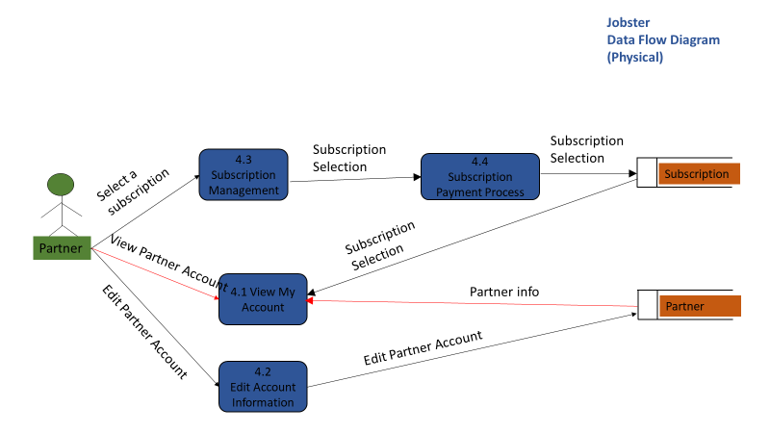

(Image 1)

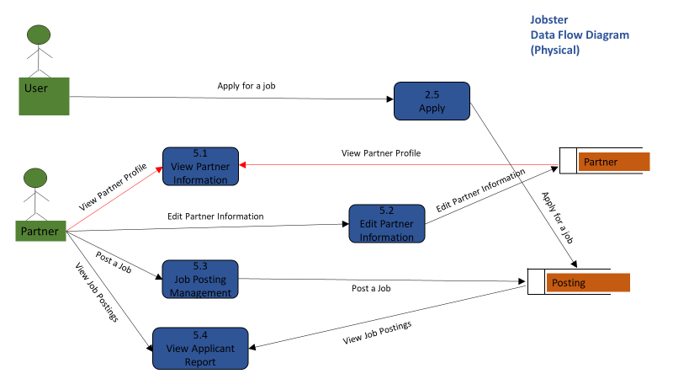(Image 2)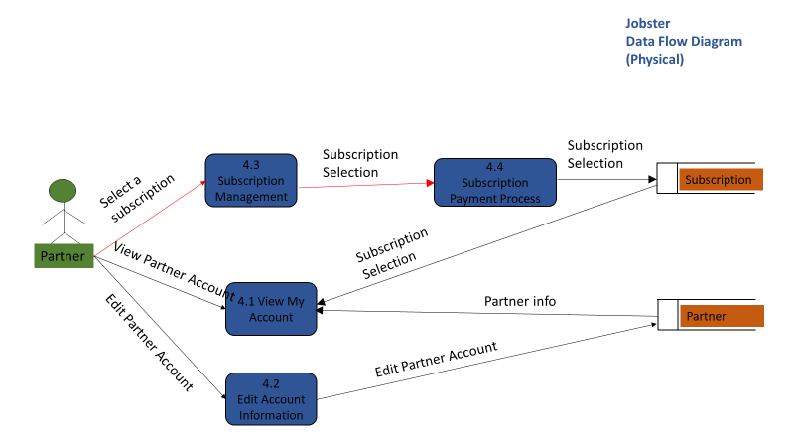

(Image 3)

(Image 4)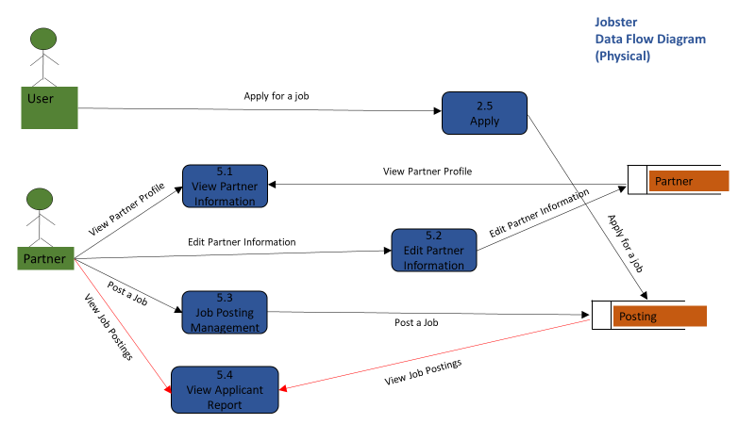

1. Data Flow Out:

**Scope:**

* U.C 2.5 Apply (Image 1)
* U.C 4.2 Edit Account Information (Image 2)
* U.C 4.3 Subscription Management (Image 3)
* U.C 4.4 Subscription Payment Process (Image 4)
* U.C 5.2 Edit Partner Information (Image 5)
* U.C 5.3 Job Posting Management (Image 6)

**Requirements:**

* When a user applies through 2.5 Apply, details of the user should get listed in 5.4 View Applicant Report.
* When a partner edits their information in 4.2 Edit Account Information, the edited information should get accurately reflected in 4.1 View Account Information.
* When a partner selects a subscription plan in 4.3 Subscription Management, the plan details should get reflected in 4.4 Subscription Payment Process.
* When a partner makes a payment for their subscription plan in 4.4 Subscription Payment Process, the plan details should get reflected in 4.1 View My Account.
* When a partner edits their information in 5.2 Edit Partner Information, the information should get reflected in 5.1 View Partner Information.
* When a partner posts a job in 5.3 Job Posting Management, the listed job should be searchable in 2.3 Search Results.

**Conditions to Apply:** After the respective join points

(Image 1)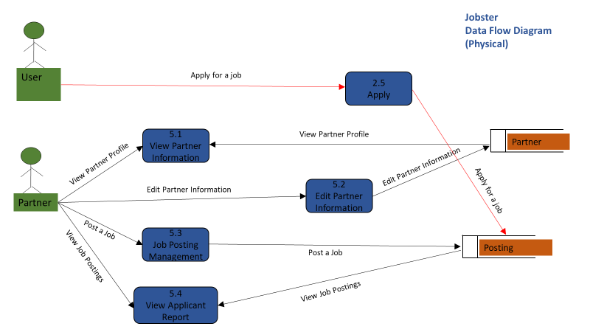

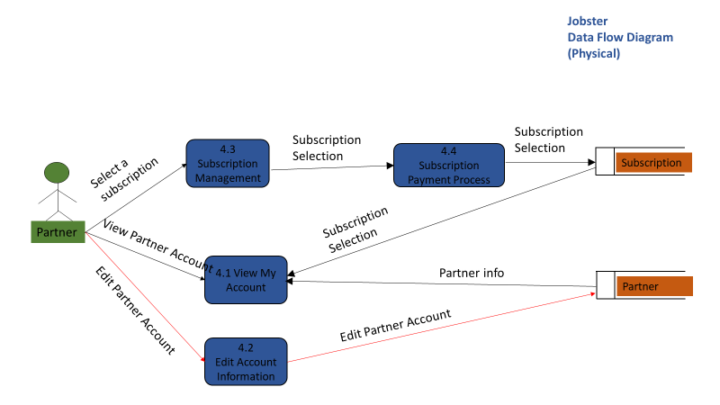(Image 2)

(Image 3)

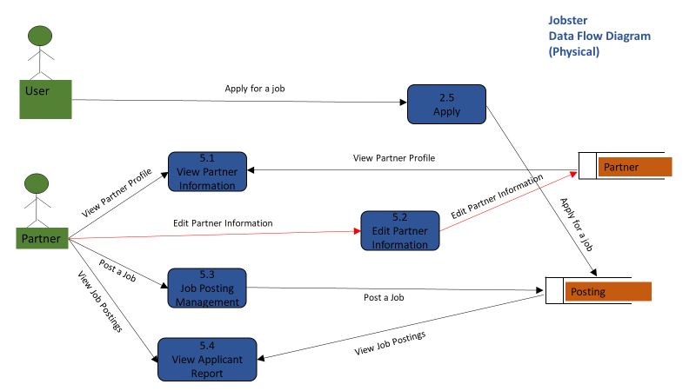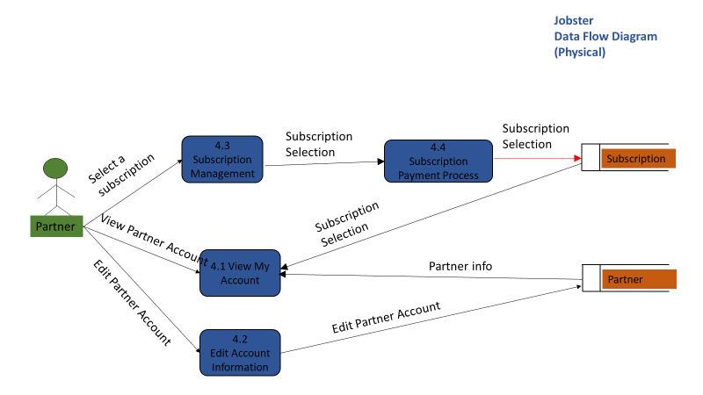(Image 4)

(Image 5)

(Image 6)